H.T No
Regulations:
A17

Sreenidhi Institute of Science and Technology
(An Autonomous Institution)
Code No: 6K704 Date: 07-Sept-2021 (FN)

B.Tech IV-Year I- Semester External Examination, Aug/Sept - 2021 (Supplementary)
FINITE ELEMENT METHOD FOR CIVIL ENGINEERS (ME)

Time: 3 Hours Max.Marks:75

Note: a) No additional answer sheets will be provided.
b) All sub-parts of a question must be answered at one place only, otherwise it will not be valued.
c) Missing data can be assumed suitably.

ANSWER ANY 5 OUT OF 8 QUESTIONS. EACH QUESTION CARRIES 15 MARKS.

Bloom's Cognitive Levels of Learning (BCLL)

Remember | L1 | Apply | L3 | Evaluate | L5
Understand | L2 | Analyze | L4 | Create | L6

 |  |  | BCLL | CO(s) | Marks
1. | a) | Derive the stress and equilibrium equations considering three-dimensional elemental volume. [8] | L4 | CO1 | [8M]
 | b) | For the bar assemblages shown in figure, determine the nodal displacements,  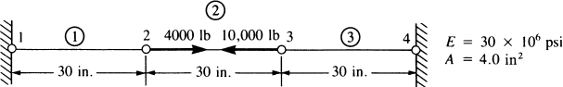  the stresses in each element, and the reactions | L5 | CO1 | [7M]
2. |  | Determine the nodal deflections, reaction forces, and stress for the truss system shown below: Take Young’s modulus = 200GPa, cross section area = 3250 mm².  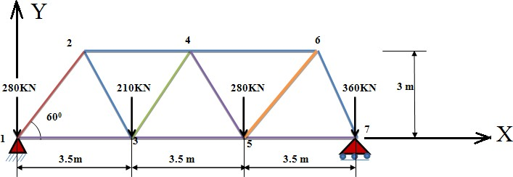 | L5 | CO2 | [15M]
3. |  | Determine the Jacobian for the (x,y) – (ξ, η) transformation for the element shown in the figure. Also find the area of the triangle.  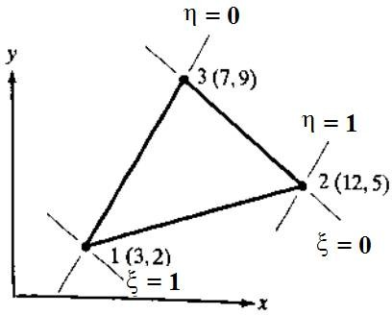 | L5 | CO3 | [15M]
4. |  | A rigid horizontal bar AB hinged at A is supported by a 1.2m long steel rod and a 2.4m long bronze rod, both rigidly fixed at the upper ends, A load of 48kN is applied at a point that is 3.2m from the hinge point A, the areas of cross-section of steel and bronze rods are 850mm2 and 650mm2 respectively. Find stress in each rod.  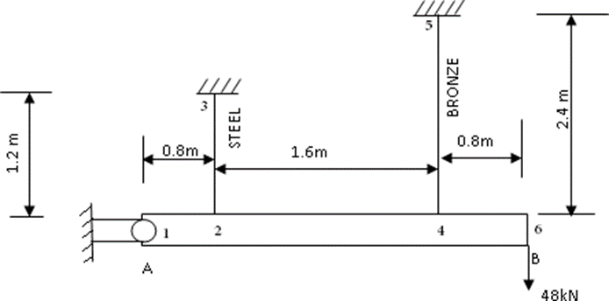 | L5 | CO4 | [8M]
5. |  | Derive the stiffness matrix for a u-noded iso-parametric axi-symmetric element. | L4 | CO5 | [15M]
6. |  | Explain overall procedure for solving structural engineering problem Using ANSYS software | L2 | CO6 | [15M]
7. | a) | Explain the constitutive relationships for plane stress and plane strain condition. Write short notes on strain-displacement relationships. | L2 | CO1 | [5M]
 | b) | For a plane stiffness triangular element with nodes A(2,3), B(5,2) & C(3,4) all units are in meters. Obtain the shape functions, N1, N2 and N3 at the point (4,5). | L2 | CO2 | [5M]
 | c) | Derive the stiffness matrix and nodal load vectors for a CST element. | L3 | CO3 | [5M]
8. | a) | Discuss the formulation of 4-noded iso-parametric element and derive the stiffness matrix for it. | L2 | CO4 | [8M]
 | b) | Write short notes on  i) Solution techniques. ii) Geometric invariance | L1 | CO5 | [7M]

-- 00 -- 00 –

